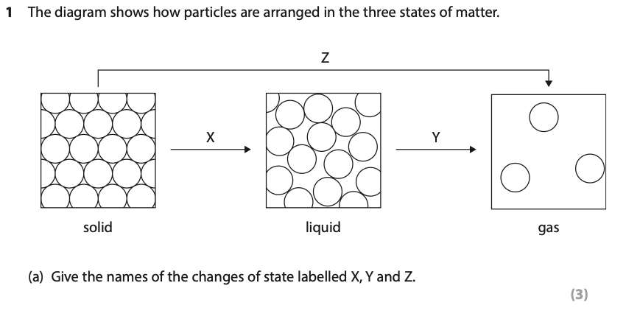
Answer______________________________________________________________________________________________________________________________________________________________________________________________________________________________________________________________________________________________

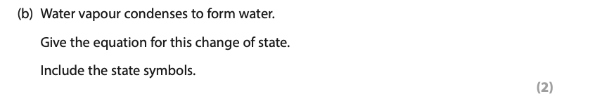
Answer______________________________________________________________________________________________________________________________________________________________________________________________________________________________________________________________________________________________

Answer______________________________________________________________________________________________________________________________________________________________________________________________________________________________________________________________________________________________
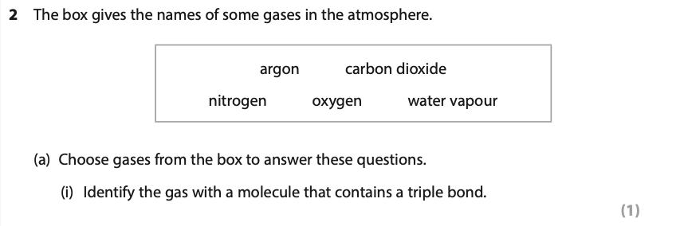
Answer___________________________________________________________________
Answer___________________________________________________________________
Answer___________________________________________________________________
Answer____________________________________________________________________________________________________________________________________________
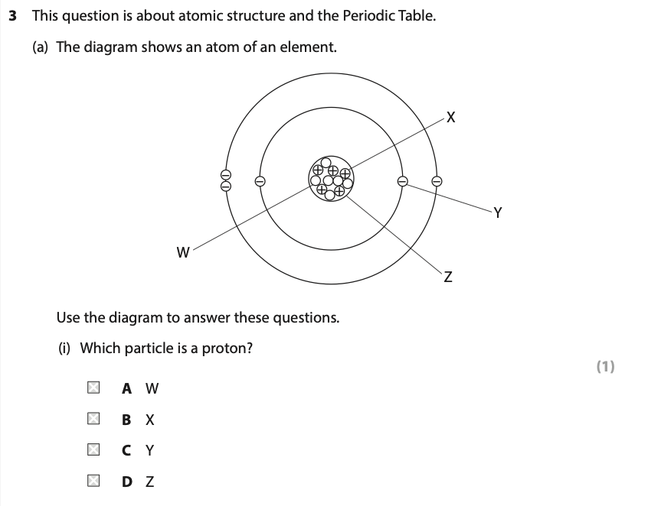
Answer_________

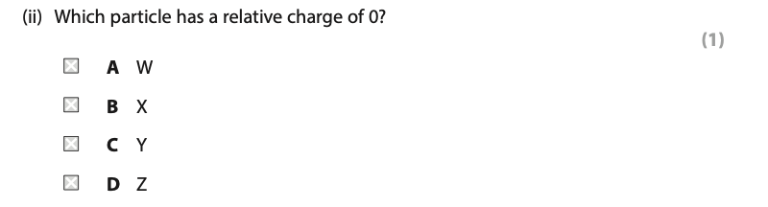
Answer_________
Answer___________________________________________________________________
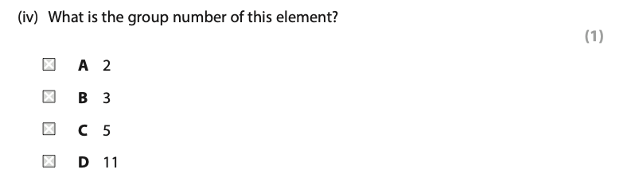
Answer________
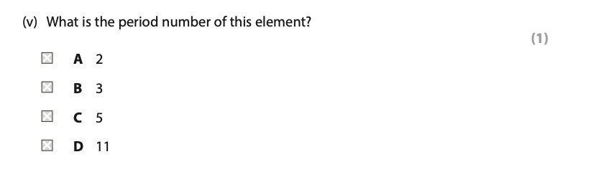
Answer________
Answer___________________________________________________________________
Answer___________________________________________________________________
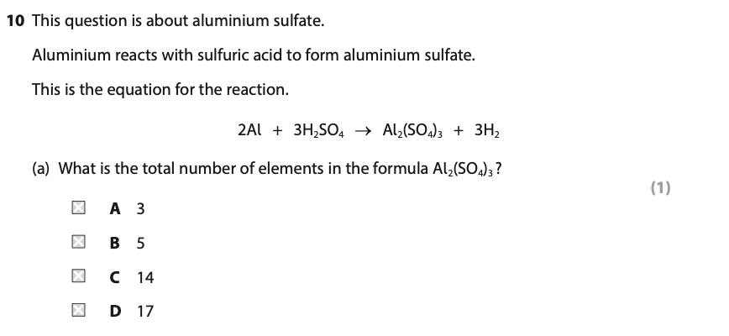
Answer______
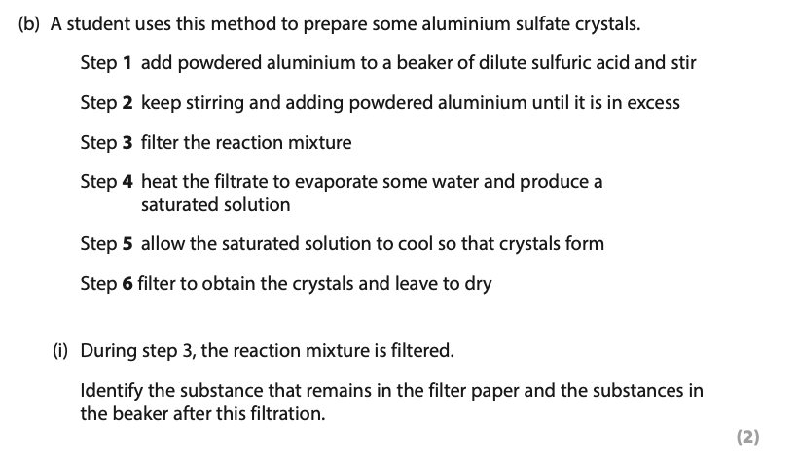
Filter paper_____________________________________________________________
Beaker________________________________________________________________

Answer_____________________________________________________________

Answer_____________________________________________________________

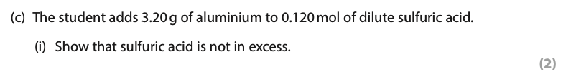
Answer_____________________________________________________________
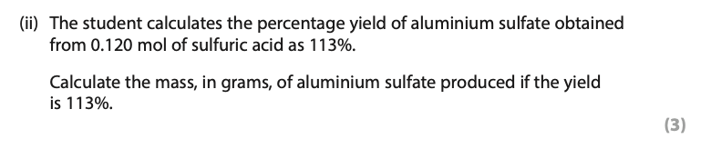
Answer_____________________________________________________________

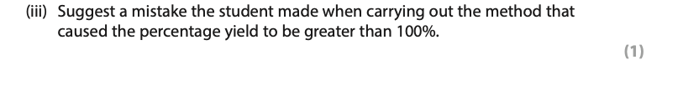
Answer_____________________________________________________________

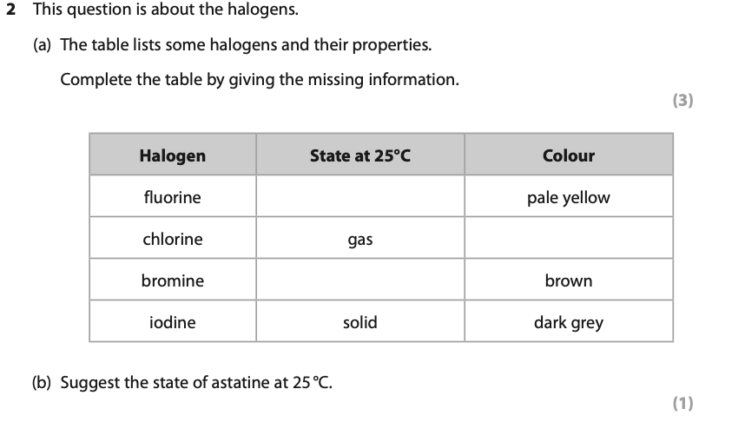
Answer_____________________________________________________________
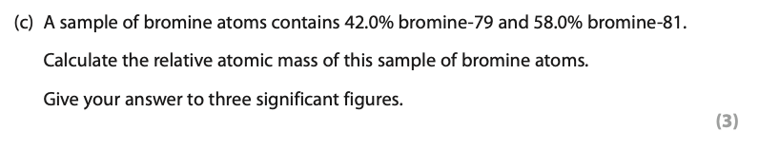
Answer_____________________________________________________________
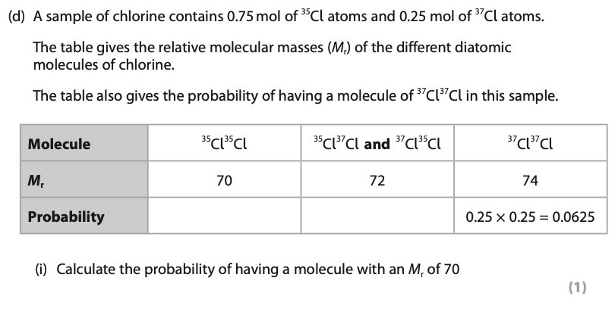
Answer_____________________________________________________________

Answer_____________________________________________________________
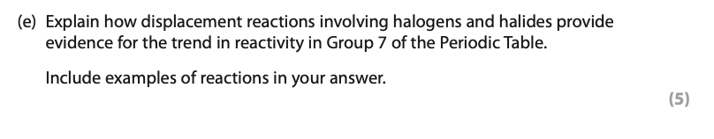
Answer_______________________________________________________
_____________________________________________________________
_____________________________________________________________
_____________________________________________________________
_____________________________________________________________
_____________________________________________________________

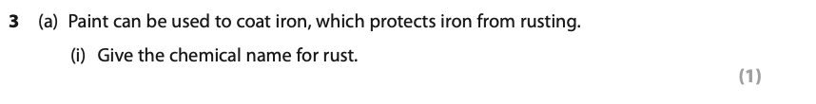
Answer_____________________________________________________________

Answer_____________________________________________________________

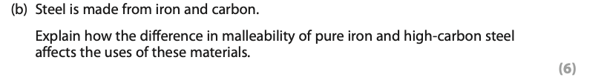
Answer_______________________________________________________
_____________________________________________________________
_____________________________________________________________
_____________________________________________________________
_____________________________________________________________
_____________________________________________________________

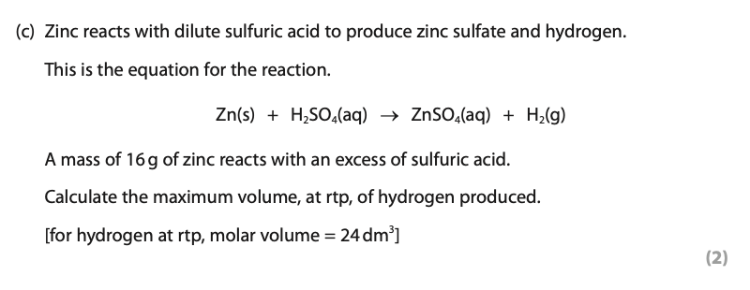

Answer_____________________________________________________________

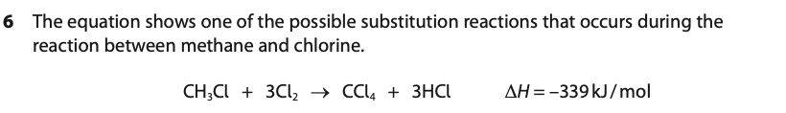
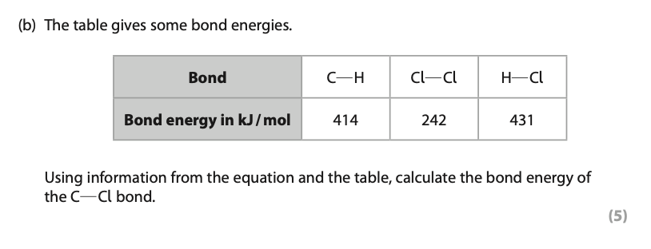
Answer_____________________________________________________________

